Simple Shell

Name: Nayera Abd El Samie
Id: 4032

Description of the overall organization

To handle commands in a simple shell there are 3 steps which are:

1) Reading command line.
2) Parsing the command line into tokens in an array of strings.
3) Execute the parsed command.

Let’s take every step in detail:

1-- Read command line:

In this project the function is called readCmmdLine
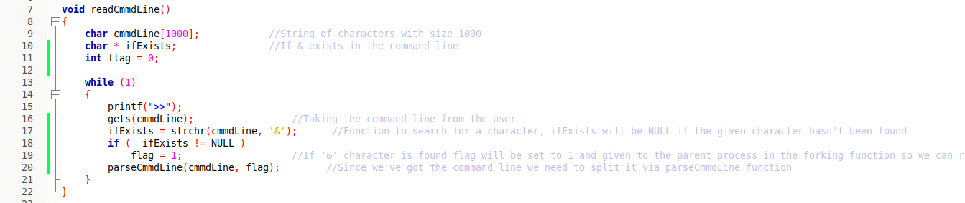
This function keeps taking command lines from the user and send them to parsing function.

2-- Parsing:

In this project the function is called parseCmmdLine
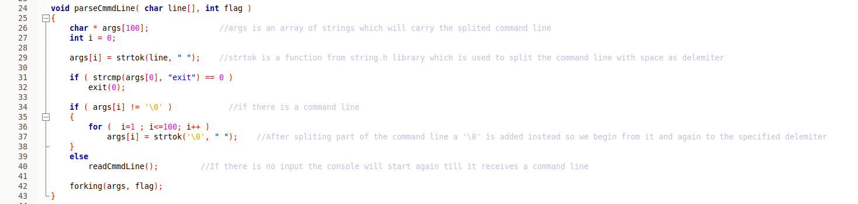
This function takes the command line, split it into stream of tokens (Array of strings) via strtok() and uses space as a delimiter.
After that, it call forking function which is:

3-- Execute:

To execute the parsed command lines function called forking is used. When fork() is called, the operating system duplicates the process and the 2 processes are running concurrently. The original process called the parent process while the duplicated process is the child process. Fork() process returns the process id “pid” which will be compared to zero.

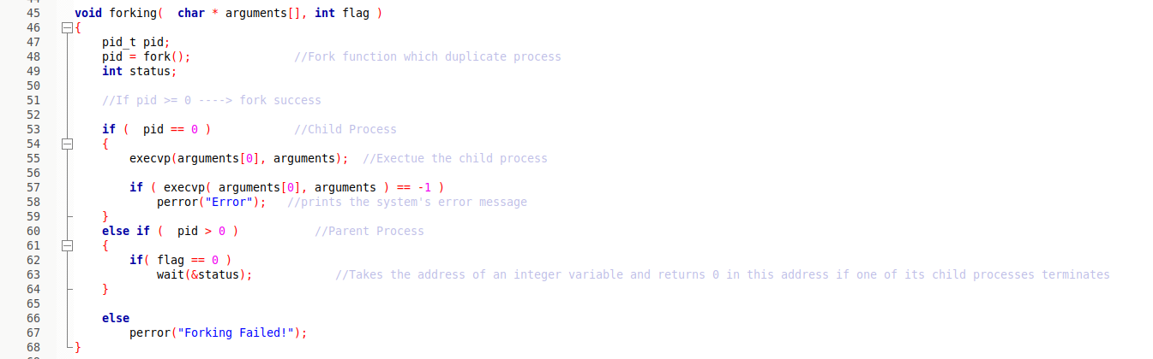
We have completed the 3 steps, however if we want to know whether the child was terminated or not we will use signal function which takes 2 parameters SIGCHLD which is the signal the parent receives and the second parameter is a function here called signalHandler that writes to a file (log file) the terminated children.

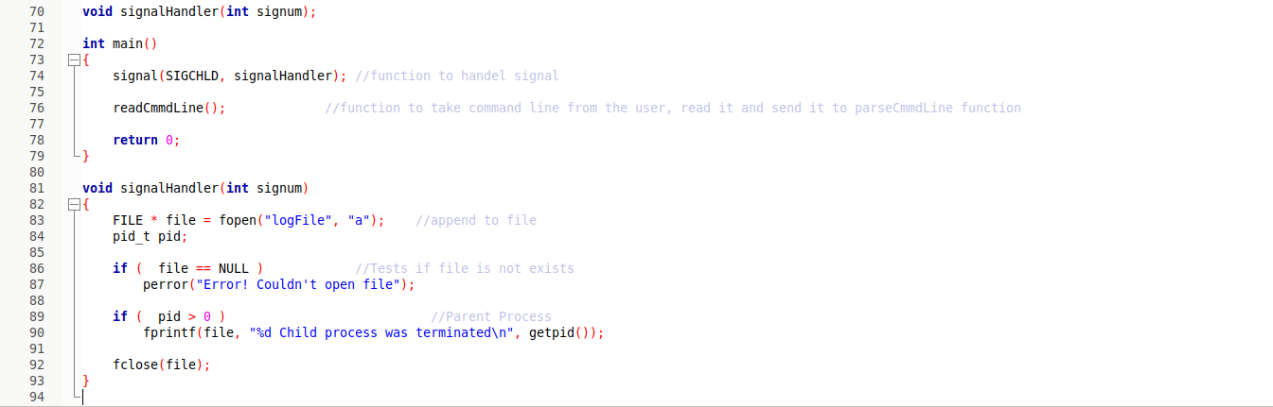

OUTPUT:

Codeblocks console:
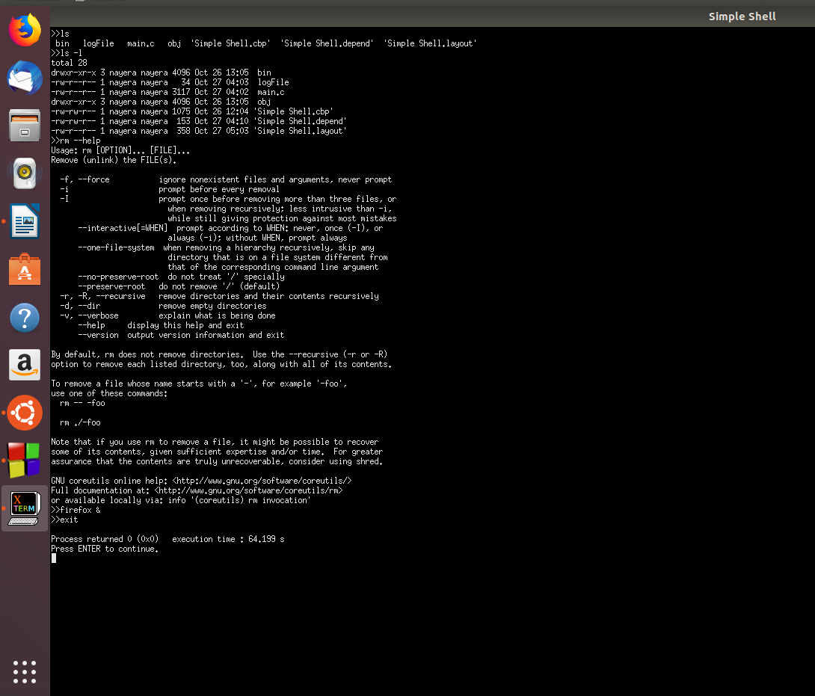

Same code but ran through the terminal:
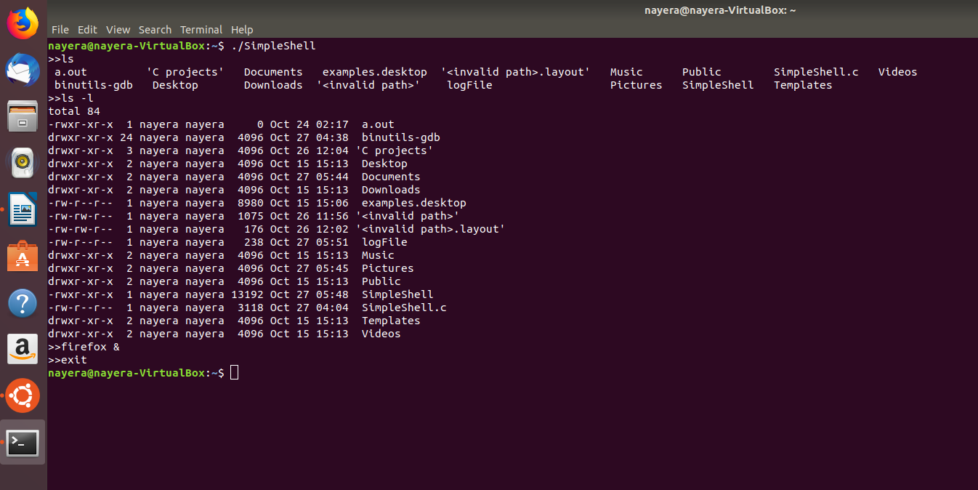
Object code:

